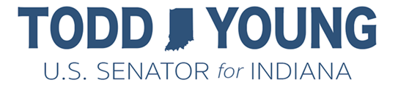­

Fighting Coronavirus

* Requires private and public health plans to provide full coverage for COVID-19 visits and testing.
* Provides $1 billion to the Public Health and Social Services Emergency Fund to allow for COVID-19 testing for the uninsured.
* Gives states additional emergency federal medical assistance.
* Provides liability protection to certain personal respiratory protective device manufacturers to increase the production of devices in high demand.

Sick and Emergency Leave

* Creates emergency paid sick leave for eligible employees who are sick or quarantined; as well as for caregivers of quarantined family members or children.
  + Full-time workers will be guaranteed two weeks of paid leave, prorated for part-time workers. Payments will be capped at $511/day for sick employees, or at two-thirds of pay for those caring for family members capped at $200/day.
* Provides temporary paid family leave for an additional 10 weeks to care for children whose school or daycare facility has closed due to the health emergency.
  + Payments will equal two-thirds pay with a cap at $200/day.
  + Small businesses with fewer than 50 employees may apply for hardship exemptions.
* Provides refundable payroll tax credits for employers to offset payments for sick leave and family leave requirements

Food Assistance

* Provides funding for nutrition assistance programs, including
  + $500 million for the Special Supplemental Nutrition Program for Women, Infants, and Children (WIC)
  + $400 million to help states and food banks
  + $250 million for nutrition programs for seniors, including home-delivered meals
* Allows states to provide additional, temporary SNAP benefits to families with children whose schools have closed due to the public health emergency.
* Permits certain school meal program requirements to be waived to ensure food is provided despite school closures.
* Waives federal SNAP work requirements temporarily

FAMILIES FIRST CORONAVIRUS RESPONSE ACT